PRACTICAL WORKBOOK



Object Oriented Programming
With Java

Name: ________________________________________

Roll No: _______________________________________

Subject Teacher:
Mr. Muhammad Owais Rehmani
Teaching Assistant in department of Artificial Intelligence

department of ARTificial Intelligence
quaid-e-awam university of engineering, science & technology
nawabshah, sindh

CERTIFICATE

This is to certify that Mr. / Miss ____________________________________ of class bearing Roll No. ________________ has carried out the necessary practical as per course of studies Object Oriented Programming for the 2nd Semester 1st Year as above in practical schedule of his journal.

Date: __________
Course Teacher Mr. Muhammad Owais Rehmani

CONTENTS

Lab Session # | OBJECT | Page No.
01 | Java compiler and Java Programs using Netbeans
02 | To perform basic I/O operations using Scannar Class of Java in a console based environment  Write a program to check whether a number is Armstrong or not
03 | GUI based input and output using dialog boxes.
04 | Getting familiar with loops in java.
05 | Getting familiar with Loop control statements (break, continue, labeled break and labeled continue)
06 | Getting familiar with decision making statements
07 | Getting familiar with Traversing arrays and Finding minimum and maximum element in an array
08 | Getting familiar with searching and sorting an array
09 | To become familiar with most common string functions in Java
10 | To become familiar with single, multi-level and multiple inheritance java
11 | To become familiar with creation & running of simple applet program in java
12 | To become familiar GUI with event handling programming in java
13 | To become familiar with Exception Handling mechanism in Java
14 | To become familiar with two ways to implement threads in java

Introduction:
The course Object Oriented Programming taught in Computer Systems Engineering intends to teach the basic concepts as well as advanced techniques of Programming based on objects and classes models.
Java was developed by a team led by James Gasling at Sun Microsystems. Sun Microsystems was purchased by Oracle in 2010. Originally called Oak, the Java was designed in 1991 for use in embedded chips in consumer electronics appliances. In 1995, renamed Java, it was redesigned for developing web applications. Java is a full-fledged and powerful language that can be used in many ways. It comes in three editions:
- Java Standard Edition (Java SE)
To develop client side applications. The applications can run standalone or as applets running from a Web browser.
- Java Enterprise Edition (Java EE)
To develop server-side applications, such as Java servlets, Java Server Pages(JSP), and Java Server Faces(JSF)
- Java Micro Edition (Java ME)
To develop applications for mobile devices, such as cell phones.

Java SE is the foundation upon which all other Java technology is based. There are many versions of java SE. The latest is Java SE 8, which we will use in these labs. Oracle releases each verion with a Java Development Toolkit (JDK). For Java SE 8, the Java Development Toolkit is called JDK 1.8 (also known as Java 8 or JDK 8).
You can view and download the latest version of Java at:

https://www.oracle.com/technetwork/java/javase/downloads/jdk-netbeans-jsp-3413139-esa.html

Practical#01
Objective:
- Java compiler and Java Programs using Netbeans

Apparatus:
- A machine, Notepad and Netbeans
Theory:
Java Notes:
- Java is case sensitive: Public is not similar to public
- Each java statement must end with semicolon ( ; )
- When you compile the java code via console; you must write the file name and his extension “filename.java”.
- After compiling the file; new file is created for the main file with the same name but with .class extensions, that’s called (The Compiled Java Source Code)
- When you run the compiled code you need to write JUST : java filename ⏎
Installing the JDK:

Installing java is a straightforward process. You just have to run the installation wizard and follow it (next >> next >> next ... etc.).

Setting the System Environment:

The first steps to start the programming with java, you need to set the system environment and adding JDK path to system variables:

Welcome to Java:
Now, you are able to start programming with JAVA, the first example we want to write code that’s print “Welcome To Java…” on console.

public class Welcome
{
public static void main (String[] args)
{
System.out.println(“WELCOME TO JAVA…”);
}
}

Now, you must to compile the code by running the console and going to the code path (where you save your file).
- Call the java compiler by writing javac filename.java ⏎
- Run the code, joust write java filename ⏎

Developing Java Programs using Netbeans

NetBeans is an integrated development environment (IDE) for developing primarily with Java. It is free, open-source and easy to learn. You can download the latest version of it form to official website:

https://netbeans.org/downloads/

After downloading and installing the latest version, run it:

Now you are ready to create your first Java program using Netbeans, but first, you need to create a project. A project is like a folder to hold Java programs and all supporting files. You need to create a project only once. Here are the steps to create a Java project:

- From File menu, New Project to display the New Project dialog box, or simply press “New Project” icon from File toolbar.

- A “New Project” dialog box will open. Select Java in the Categories section and Java Application in the Projects section and click Next to display the New Java Application.

5
- In the “Project Name” field, you should type a name that gives an idea of what the project is really doing.

- Click finish to create the project

Comments:

Comments in Java are an integral part of any program. They help the person reading the code (often you) better understand the intent and functionality of the program. There are three types of comments in Java:
- Line comments (beginning with //) are used for commenting on steps inside a method.
- Block comments (beginning with /* and end with */) are used for comments with multi lines.
- Javadoc comments (begin with /** and end with */) are used for commenting on an entire class or an entire method.
Comments (colored by Gray color in Netbeans) are ignored while compiling the code and do not be included in compiling process, so we can easily remove them from our small projects.
Now we are going to write and execute our first program, which prints Welcome Message on the Console:

//package firstnbproject;
public class FirstNBProject {
public static void main(String[] args) {
System.out.println("WELCOME TO JAVA...");
}
}

Write the code in the Edit pane in Netbeans, then try to run the file: right-click in the Edit pane to display a context menu and choose Run File, or simply press (Shift + F6).

JOption Pane:

Now let’s make some modifications to the code, to print the Welcome message in a Dialog Box:

//package firstnbproject;
import javax.swing.JOptionPane;
public class FirstNBProject {
public static void main(String[] args) {
JOptionPane.showMessageDialog(null, "WELCOME JOPTION PANE ☺");
}
}

Reading input from user:

There are many ways for getting input from the user, the simplest one is using “Scanner” class. The next program asks the user to enter a number (radius of a circle) and the program calculates the area of the circle and print the result to the console:

//package firstnbproject;
public class FirstNBProject {
public static void main(String[] args) {
Scanner input = new Scanner(System.in);
System.out.print("Please enter the radius: ");
// read a number
int radius = input.nextInt();
// calculate the area
double area = 3.14 * radius * radius;
// print the result to the Console
System.out.println("Area is: " + area);
}
}

Exercise:
1. Write java code that print in steps for compiling the java code using console.
The result must be like this:

2. Write a simple java code that read from scanner the user name and print it into screen and show message dialog with the entered user name.

Practical#02
Objective:
- To perform basic I/O operations using Scannar Class of Java in a console based environment
- Write a program to check whether a number is Armstrong or not

Apparatus:
- A machine with JDK, Notepad++ and Netbeans
Theory:

Input data from Java Console:
Scanner Class
- Scanner is a class in java.util package used for obtaining the input of the primitive types like int, double, etc. and strings. It is the easiest way to read input in a Java program from console
- To create an object of Scanner class, we usually pass the predefined object System.in, which represents the standard input stream. We may pass an object of class File if we want to read input from a file.
- To read numerical values of a certain data type XYZ, the function to use is nextXYZ(). For example, to read a value of type short, we can use nextShort()
- To read strings, we use nextLine().

To read a single character, we use next().charAt(0). next() function returns the next token/word in the input as a string and charAt(0) function returns the first character in that string.

// Java program to read data of various types using Scanner class.
import java.util.Scanner;
public class ScannerDemo
{
public static void main(String[] args)
{
//Declare the object and initialize with predefined standard input object
Scanner sc = new Scanner(System.in);
// String input
System.out.print("enter your name?");
String name = sc.nextLine();
System.out.print("enter your gender?");
char gender = sc.next().charAt(0);
// Numerical data input byte, short and float can be read using similar-named functions.
System.out.print("enter your age?");
int age = sc.nextInt();
System.out.print("enter your mobile number?");
long mobileNo = sc.nextLong();
System.out.print("enter your cgpa?");
double cgpa = sc.nextDouble();
// Print the values to check if the input was correctly obtained.
System.out.println("Name: "+name);
System.out.println("Gender: "+gender);
System.out.println("Age: "+age);
System.out.println("Mobile Number: "+mobileNo);
System.out.println("CGPA: "+cgpa);
}
}

Output of the program

Armstrong numbers:
An Armstrong of three digits is an integer such that the sum of the cubes of its digits is equal to the number itself. The various examples of Armstrong numbers are 153,370,371,407.

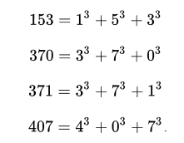

Source Code:

/* Java Program to check whether a three digit number is Armstrong or not*/
import java.util.Scanner;
class armstrong
{
public static void main(String args[])
{
int number=0,sum=0,rem=0,cube=0,temp=0;
Scanner scan=new Scanner(System.in);
System.out.println("Enter a number: ");
number=scan.nextInt();
System.out.println("The number entered is:"+" " +number );
temp=number;

while(number!=0)
{
rem=number%10;
cube=(int)Math.pow(rem,3);
sum=sum+cube;
number=number/10;
}
if(sum==temp)
System.out.println(temp+" "+"is an armstrong number");
else
System.out.println(temp+" "+"is not armstrong number");

}
}

OUTPUT:

CONCLUSIONS:
So after doing the above study we have understood how to create a class and a main function in java. In addition we learned the logic of Armstrong number.

Questions:
1. What does static keyword mean?
2. What is an Armstrong number?
3. What is the use of import keyword
4. How is java different from C++
5. What is the use of scan keyword?

Exercise:
- Write a program in java which asks your age and class Roll Number by using the Scanner class. Also Display both age and class Roll Number.
- Write a program in java using scanner class which gets two numbers as input and displays their sum.

References:
1. Java : The complete Reference by Herbertz Schildt, Oracle Press
2. Java: Black Book by Steven Holzner
3. Java: How to Program by Deitel and Deitel

PRACTICAL#03

Object: GUI based input and output using dialog boxes.

Apparatus:
- A machine with pre-installed JDK, Notepad
Theory

- JOptionPane Class allows us to use dialog boxes
- Dialog Box – is a small graphical window that displays a message to the user or request input. We can quickly display dialog boxes with JOptionPane class.
- Types of DIALOG BOXES
  - Message Dialog – a dialog box that displays a message; an OK button is also displayed.
  - Input Dialog – dialog box that prompts the user for input & provides text field where input is typed; an OK button and a CANCEL button are also displayed.
- Beginning Statement in your code when using JoptionPane:
  - import javax. swing.JOptionPane;
    - Purpose: this statement tells the compiler where to find the JOptionPane class, and make it available to your program.
    - Switng Package has classes for using Graphical User Interfaces (GUIs)

Message Dialog Boxes
- showMessageDialog method- is used to display a message dialog box.
- Call method showMessageDialog of class JOptionPane
  - Requires four arguments
    - First argument: null
    - Second: string to display
    - Third: string in title bar (optional by default Message)
    - Fourth: type of message dialog with icon (optional)
- JOptionPane.showMessageDialog(null,"The sum is "+sum, "Results“,JOptionPane.PLAIN_MESSAGE);
- showMessageDialog is a static method of class JOptionPane
    - static methods called using class name, dot (.) then method name

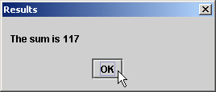

- Input Dialog Box
  - InputDialog method – to display an input dialog in JOptionPane class.
  - Statement to call the method: String name;
  - name = JOptionPane.showInputDialog(“Enter first number”);
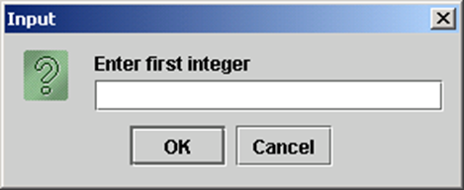

Example program: Write a Java program to find area of rectangle using input output dialog box.

import javax.swing.JOptionPane; // Needed for Dialog Box
public class RectangleTest
{
public static void main(String[] args)
{
String input; // To hold String input. output
int length; // To hold length.
int width; // To hold width.
int area; // To hold area.
// Prompt user to input length.
input = JOptionPane.showInputDialog("Enter Length");
// Convert the String input to an int.
length = Integer.parseInt(input); //Prompt user to input width.
input = JOptionPane.showInputDialog("Enter Width");
// Convert the String input to an int.
width = Integer.parseInt(input);
// Calculate area of rectangle.
area = length * width;
// Display area of rectangle.
JOptionPane.showMessageDialog(null, "Area of rectangle is " + area);
}
}

Program Output
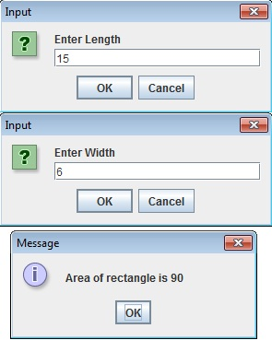

Exercise
- Write a program to calculate and display area and circumference of circle. Have the user input radius of a circle and display area and circumference of a circle. Use dialog boxes for input and output.
- Write a program to calculate and display area and circumference of circle. Have the user input radius of a circle and display area and circumference of a circle. Use System.in & System.out for input and output on MS Dos prompt.

PRACTICAL#04
Object : Getting familiar with loops in java.

Apparatus:
- A machine with pre-installed JDK, Notepad
Theory

Comparison | for loop | while loop | do while loop
Introduction | The Java for loop is a control flow statement that iterates a part of the programs multiple times. | The Java while loop is a control flow statement that executes a part of the programs repeatedly on the basis of given boolean condition. | The Java do while loop is a control flow statement that executes a part of the programs at least once and the further execution depends upon the given boolean condition.
When to use | If the number of iteration is fixed, it is recommended to use for loop. | If the number of iteration is not fixed, it is recommended to use while loop. | If the number of iteration is not fixed and you must have to execute the loop at least once, it is recommended to use the do-while loop.
Syntax | for(init;condition;incr/decr){ // code to be executed } | while(condition){ //code to be executed } | do{ //code to be executed }while(condition);
Example | //for loop for(int i=1;i<=10;i++){ System.out.println(i); } | //while loop int i=1; while(i<=10){ System.out.println(i); i++; } | //do-while loop int i=1; do{ System.out.println(i); i++; }while(i<=10);
Syntax for infinitive loop | for(;;){ //code to be executed } | while(true){ //code to be executed } | do{ //code to be executed }while(true);

Program#01: To find the factorial of a number

import java.util.Scanner;
public class Factorial
{
public static void main(String[] args)
{
long fact=1;
int num;
Scanner input=new Scanner(System.in);
System.out.print("Enter any number>>");
num=input.nextInt();
for(int i=1;i<=num;i++)
{
fact=fact*i;
}
System.out.println("factoral="+fact);
}
}

Program2: to generate and display first n fibonanci numbers 0,1,1,2,3..

import java.util.Scanner;
public class Fibonanci
{
public static void main(String[] args)
{
int n, t1 = 0, t2 = 1;
Scanner input=new Scanner(System.in);
System.out.println("Enter the value of n>>");
n=input.nextInt();
System.out.print("First " + n + " terms are ");
for (int i = 1; i <= n; ++i)
{
System.out.print(t1 + " , ");
int sum = t1 + t2;
t1 = t2;
t2 = sum;
}
}
}

Program3: To find the factorial of a number using while loop

import java.util.Scanner;
public class FactorialWhile
{
public static void main(String[] args)
{
long fact=1;int num;
Scanner input=new Scanner(System.in);
System.out.print("Enter any number>>");
num=input.nextInt();
int i=1;
while(i<=num)
{
fact=fact*i;
i++;
}
System.out.println("factoral="+fact);
}
}

Program4: to find the factorial of a number using Do-while loop

import java.util.Scanner;
public class FactorialDoWhile
{
public static void main(String[] args)
{
int num;
char choice;
do
{
Scanner input=new Scanner(System.in);
System.out.println("Enter any number>>");
num=input.nextInt();
long fact=1;
for(int i=1;i<=num;i++)
{
fact=fact*i;
}
System.out.println("factoral of number "+num+" is "+fact);
System.out.println("do you want to continue yes or no");
choice=input.next().charAt(0);
}
while(choice!='n');
}
}

Enhanced For Loop

- java also includes another version of for loop introduced in Java 5.
- Also called for each loop
- Enhanced for loop provides a simpler way to iterate through the elements of a collection or array.
- It is inflexible and should be used only when there is a need to iterate through the elements in sequential manner without knowing the index of currently processed element.
- Syntax:
for (type variableName : arrayName)
{
// code block to be executed
}
Example:

String[] cars = {"Volvo", "BMW", "Ford", "Mazda"};
for (String i : cars)
{
System.out.println(i);
}

Exercise
01: Rewrite the factorial program using for loop so that you can get input and show output using Dialog boxes.
02 Modify fibonanci program so that instead displaying first n fibonanci numbers the program should display fibonanic numbers up to particular limit? Which loop is preferable in this scenario and why?
3 Rewrite factorial of a number using while loop so that you can get input and show output using Dialog boxes.

PRACTICAL#05
Object
Getting familiar with Loop control statements (break, continue, labeled break and labeled continue)
Apparatus:
- A machine with pre-installed JDK, Notepad
Theory
- Loop control statements change execution from its normal sequence.
- When execution leaves a scope, all automatic objects that were created in that scope are destroyed.
- Java supports the following control statements.

Sr.No. | Control Statement & Description
1 | Break statement Terminates the loop or switch statement and transfers execution to the statement immediately following the loop or switch.
2 | continue statement Causes the loop to skip the remainder of its body and immediately retest its condition prior to reiterating.
3 | Labeled Break When this break statement is encountered with the label/name of the loop, it skips the execution any statement after it and takes the control right out of this labelled loop.
4 | Labeled continue When this continue statement is encountered with the label/name of the loop, it skips the execution any statement within the loop for the current iteration and continues with the next iteration and condition checking in the labelled loop.

Program1: to check whether the given number is prime or not a prime number

import java.util.Scanner;
public class PrimeCheck
{
public static void main(String[] args)
{
int num;
boolean isPrime=true;
Scanner input= new Scanner(System.in);
System.out.println("Enter any number:");
num=input.nextInt();
input.close();
for(int i=2;i<=num/2;i++)
{
if(num%i==0)
{
isPrime=false;
break;
}
}
if(isPrime)
System.out.println(num + " is a Prime Number");
else
System.out.println(num + " is not a Prime Number");
}
}

Program2: to display prime numbers within limit

import java.util.Scanner;
public class PrimeLimit
{
public static void main(String[] args)
{
int limit;
Scanner input=new Scanner(System.in);
boolean isPrime;
System.out.print("Enter limit>>");
limit=input.nextInt();
for (int j=2;j<=limit;j++)
{
isPrime=true;
for(int i=2;i<=j/2;i++)
{
if(j%i==0)
{
isPrime=false;
break;
}
}
if(isPrime)
System.out.print(j + " , ");
}
}
}

Program3: to display all numbers from 1 to 100 except divisible by 5

public class ContinueDemo
{
public static void main(String args[])
{
for (int i = 1; i <= 100; i++)
{
if (i%5 == 0)
continue;
System.out.print(i + " ");
}
}
}

Program4: Tester Program

public class Tester {
public static void main(String args[]) {
first:
for (int i = 0; i < 3; i++) {
for (int j = 0; j< 3; j++){
if(i == 1){
continue first;
}
System.out.print(" [i = " + i + ", j = " + j + "] ");
}
}
System.out.println();

second:
for (int i = 0; i < 3; i++) {
for (int j = 0; j< 3; j++){
if(i == 1){
break second;
}
System.out.print(" [i = " + i + ", j = " + j + "] ");
}
}
}
}

Exercise
01: Modify prime numbers with limit program so that instead displaying prime numbers within limit, the program should display first n prime numbers?

PRACTICAL#06
Object: Getting familiar with decision making statements
Apparatus:
- A machine with pre-installed JDK, Notepad
Theory
- Java programming language provides following types of decision making statements.

Sr. No | Statement & Description
1 | if statement An if statement consists of a boolean expression followed by one or more statements.
2 | if...else statementAn if statement can be followed by an optional else statement, which executes when the boolean expression is false.
3 | nested if statementYou can use one if or else if statement inside another if or else if statement(s).
4 | switch statementA switch statement allows a variable to be tested for equality against a list of values.

Program1# If Demo Program
class IfDemo
{
public static void main(String args[])
{
int age;
Scanner input=new Scanner(System.in);
System.out.println("Enter your age");
age=input.nextInt();
if (age<=30)
System.out.println("Your are young");
}
}

Program#02: To display whether entered number by user is Even or ODD

import java.util.Scanner;
class CheckEvenOdd
{
public static void main(String args[])
{
int num;
System.out.println("Enter an Integer number:");
//The input provided by user is stored in num
Scanner input = new Scanner(System.in);
num = input.nextInt();
//If number is divisible by 2 then it's an even number else odd number
if ( num % 2 == 0 )
System.out.println("Entered number is even");
else
System.out.println("Entered number is odd");
}
}

Program#03: Java program to illustrate if-else-if ladder

class ifelseifDemo
{
public static void main(String args[])
{
int num = 20;
if (num== 10)
System.out.println("number is 10");
else if (num== 15)
System.out.println("number is 15");
else if (num== 20)
System.out.println("number is 20");
else
System.out.println("number is not 10,15 or 20");
}
}

Program#04: Calculator program

import java.util.Scanner;
public class CalcSwitch {
public static void main(String[] args) {
Scanner reader = new Scanner(System.in);
System.out.print("Enter two numbers: ");
// nextDouble() reads the next double from the keyboard
double first = reader.nextDouble();
double second = reader.nextDouble();
System.out.print("Enter an operator (+, -, *, /): ");
char operator = reader.next().charAt(0);
double result;
switch(operator)
{
case '+':
result = first + second;
break;
case '-':
result = first - second;
break;
case '*':
result = first * second;
break;
case '/':
result = first / second;
break;
// operator doesn't match any case constant (+, -, *, /)
default:
System.out.printf("Error! operator is not correct");
return;
}

System.out.printf("%.1f %c %.1f = %.1f", first, operator, second, result);
}
}

Exercise
01: Write Calculator program using nested if else if statements

PRACTICAL#07
Object: Getting familiar with Traversing arrays and Finding minimum and maximum element in an array.

Apparatus:
- A machine with pre-installed JDK, Notepad
Theory
Traversing arrays
Accessing each element of an array is called Traversing. Normally we use FOR loop to enter all elements of an array and to display all elements of an array.

Write a Java program that calculates average of elements in an array. Ask user to enter number of elements in array and then calculates and display average.

//program#01: Average of numbers
import java.util.Scanner;
public class AvgNumbers
{
public static void main(String[] args)
{
int N,numar[],i;
Scanner input=new Scanner(System.in);
System.out.print("Enter the value of N>>");
N=input.nextInt();
numar=new int[N];
System.out.println("Enter elements of array>>");
for(i=0;i<N;i++)
numar[i]=input.nextInt();
int total=0;
double avg;
for(i=0;i<N;i++)
total+=numar[i];
avg=(double)total/N;
System.out.println("The average of "+N+" numbers is "+avg);
}
}

Finding Minimum and Maximum

//program#02: finding minimum number from array of numbers
import java.util.Scanner;
public class MaxArray
{
public static void main(String[] args)
{
int N,numar[],i;
Scanner input=new Scanner(System.in);
System.out.print("Enter the value of N>>");
N=input.nextInt();
numar=new int[N];
System.out.println("Enter elements of array>>");
for(i=0;i<N;i++)
numar[i]=input.nextInt();
int min=numar[0];
for(i=1;i<N;i++)
{
if(min>numar[i])
min=numar[i];
}
System.out.println("The maximum element in an array is "+min);
}
}

//program#03: finding maximum number from array of numbers
import java.util.Scanner;
public class MaxArray
{
public static void main(String[] args)
{
int N,numar[],i;
Scanner input=new Scanner(System.in);
System.out.print("Enter the value of N>>");
N=input.nextInt();
numar=new int[N];
System.out.println("Enter elements of array>>");
for(i=0;i<N;i++)
numar[i]=input.nextInt();
int max=numar[0];
for(i=1;i<N;i++)
{
if(max<numar[i])
max=numar[i];
}
System.out.println("The maximum element in an array is "+max);
}
}

//program#04: finding minimum & maximum numbers from array of numbers
import java.util.Scanner;
public class MinMax
{
public static void main(String[] args)
{
int N,numar[],i;
Scanner input=new Scanner(System.in);
System.out.print("Enter the value of N>>");
N=input.nextInt();
numar=new int[N];
System.out.println("Enter elements of array>>");
for(i=0;i<N;i++)
numar[i]=input.nextInt();
int min=numar[0];
int max=numar[0];
for(i=1;i<N;i++)
{
if(min>numar[i])
min=numar[i];
if(max<numar[i])
max=numar[i];
}
System.out.println("The minimum element in an array is "+min);
System.out.println("The maximum element in an array is "+max);
}

Exercise
1) Write java program to find the minimum or maximum element in an array of elements depend upon choice entered by the user

2) Write java program to add two matrices entered by the user

PRACTICAL#08
Object: Getting familiar with searching and sorting an array.

Apparatus:
- A machine with pre-installed JDK, Notepad
Theory
Searching
- Two Searching techniques
  - Sequential or Linear Search
  - Binary Search
- Sequential search is also known as linear or serial search. It follows the following step to search a value in array.
- Visit the first element of array and compare its value with required value.
- If the value of array matches with the desired value, the search is complete.
- If the value of array does not match, move to next element and repeat same process.

//program#01: Linear Search program
import java.util.Scanner;
public class LinearSearch
{
public static void main(String[] args)
{
int numlist[]={2,3,65,76,34,23,10,20};
int num;
Scanner input=new Scanner(System.in);
System.out.print("Enter number you want to search>>");
num=input.nextInt();
int loc=-1;
for(int i=0;i<numlist.length;i++)
{
if(num==numlist[i])
{
loc=i;
break;
}
}
if(loc!=-1)
System.out.print("number fournd in the list and its location loc= "+loc);
else
System.out.print("number not found in the list");
}
}

Binary search is a quicker method of searching for value in the array. Binary search is very quick but it can only search on sorted array. It cannot be applied on an unsorted array.
- It locates the middle element of array and compare with desired number.
- If they are equal, search is successful and the index of middle element is returned.
- If they are not equal, it reduces the search to half of the array.
- If the search number is less than the middle element, it searches the first half of array.
- Otherwise it searches the second half of the array. The process continues until the required number is found or loop completes without successful search

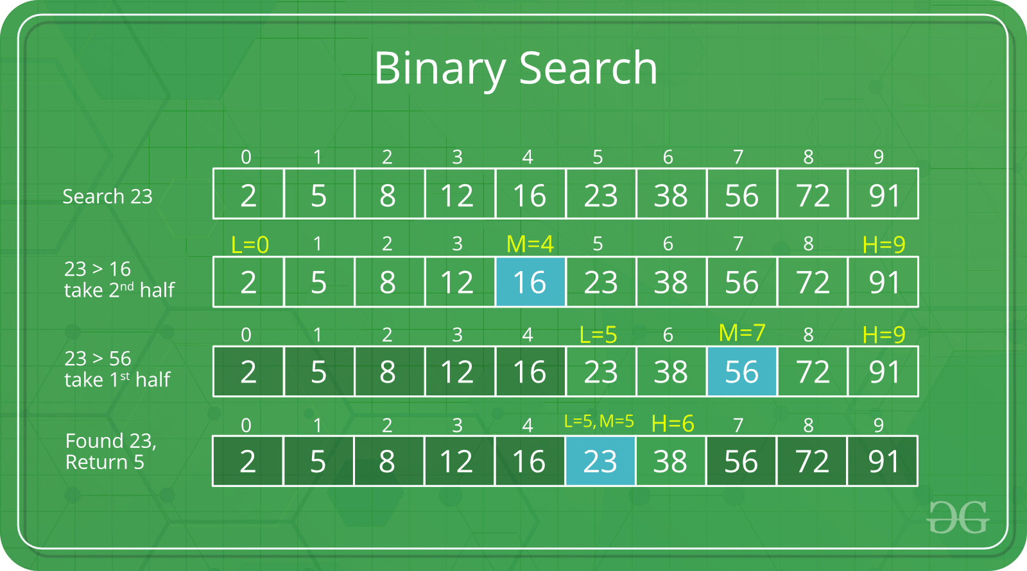

//program#02: Binary Search program
import java.util.Scanner;
public class BinarySearch
{
public static void main(String[] args)
{
int num, first, last, middle;
int numlist[]={10,20,30,40,50,60,70,80,90,100};
Scanner input = new Scanner(System.in);
System.out.println("Enter number you want to search:");
num = input.nextInt();
first = 0;
int N=numlist.length;
last =N-1;
middle = (first + last)/2;
while( first <= last & num!=numlist[middle] )
{
if ( num<numlist[middle] )
last = middle - 1;
else
first=middle+1;
middle = (first + last)/2;
}
if(num==numlist[middle])
System.out.println("number found in the list and its loccation loc="+middle);
else
System.out.println("number not found in the list ");
}
}

Sorting
- Sorting is a process of arranging the value of array in a particular order. An array can be sorted in two order.
  - Ascending Order
  - Descending Order

- Various sorting algorithms/techniques
  - Bubble Sort
  - Selection Sort
  - Insertion Sort
  - Quick Sort
  - Merge Sort

Bubble Sorting
- Bubble Sort is also known as exchange sort. It repeatedly visits the array and compares two items at a time. It works as follows:
- Compare adjacent element. If the first is greater than the second, swap them.
- Repeat this for each pair of adjacent element, starting with the first two and ending with the last two. (at this point last element should be greatest).
- Repeat the step for all elements except the last one.
- Keep repeating for one fewer element each time until there are no pairs to compare

//program#07: Bubble Sort program
import java.util.Scanner;
public class BubbleSort
{
public static void main(String[] args)
{
int numlist[],N,i,j,temp;
Scanner input = new Scanner(System.in);
System.out.print("Enter number of elements in the list>>");
N=input.nextInt();
numlist= new int[N];
System.out.println("Enter " + N + " integer numbers");
for (i= 0; i <N; i++)
numlist[i] = input.nextInt();
System.out.println("Before sorting the numbers in the list are>>");
for(i=0;i<N;i++)
System.out.print(numlist[i]+" ");
for(i=0;i<N-1;i++)
for(j=0;j<N-1-i;j++)
if(numlist[j]>numlist[j+1])
{
temp=numlist[j];
numlist[j]=numlist[j+1];
numlist[j+1]=temp;
}
System.out.println("\nthe numbers in the list after sorting are");
for(i=0;i<N;i++)
System.out.print(numlist[i]+" ");
}
}

Exercise
1) Write java program to perform subtraction between two matrices entered by the user
2) Write java program to perform multiplication between two matrices entered by the user

PRACTICAL#09

Objective:
To become familiar with most common string functions in Java
Apparatus:
- A machine with pre-installed JDK, Notepad
Theory:Strings, which are widely used in Java programming, are a sequence of characters. In the Java programming language, strings are objects.
The Java platform provides the String class to create and manipulate strings.

Creating Strings:
The most direct way to create a string is to write:
String greeting ="Hello world!";
Whenever it encounters a string literal in your code, the compiler creates a String object with its value in this case, "Hello world!'.
As with any other object, you can create String objects by using the new keyword and a constructor. The String class has eleven constructors that allow you to provide the initial value of the string using different sources, such as an array of characters.
publicclassStringDemo{

publicstaticvoid main(Stringargs[]){
char[]helloArray={'h','e','l','l','o','.'};
StringhelloString=newString(helloArray);
System.out.println(helloString);
}
}
This would produce the following result:
hello.
Note: The String class is immutable, so that once it is created a String object cannot be changed. If there is a necessity to make a lot of modifications to Strings of characters, then you should use String Buffer & String BuilderClasses.

String Length:
Methods used to obtain information about an object are known as accessor methods. One accessor method that you can use with strings is the length() method, which returns the number of characters contained in the string object.
Below given program is an example of length() , method String class.
publicclassStringDemo{

publicstaticvoid main(Stringargs[]){
String palindrome ="Dot saw I was Tod";
intlen=palindrome.length();
System.out.println("String Length is : "+len);
}
}
This would produce the following result:
StringLengthis:17

Concatenating Strings:
The String class includes a method for concatenating two strings:
string1.concat(string2);
This returns a new string that is string1 with string2 added to it at the end. You can also use the concat() method with string literals, as in:
"My name is ".concat("Zara");
Strings are more commonly concatenated with the + operator, as in:
"Hello,"+" world"+"!"
which results in:
"Hello, world!"
Let us look at the following example:
publicclassStringDemo{

publicstaticvoid main(Stringargs[]){
String string1 ="saw I was ";
System.out.println("Dot "+ string1 +"Tod");
}
}
This would produce the following result:
Dot saw I was Tod

Creating Format Strings:
You have printf() and format() methods to print output with formatted numbers. The String class has an equivalent class method, format(), that returns a String object rather than a PrintStream object.
Using String's static format() method allows you to create a formatted string that you can reuse, as opposed to a one-time print statement. For example, instead of:
System.out.printf("The value of the float variable is "+
"%f, while the value of the integer "+
"variable is %d, and the string "+
"is %s",floatVar,intVar,stringVar);
you can write:
String fs;
fs=String.format("The value of the float variable is "+
"%f, while the value of the integer "+
"variable is %d, and the string "+
"is %s",floatVar,intVar,stringVar);
System.out.println(fs);
Conclusion: This practical lets you enable to use some of the String methods.
Review Questions:
01: Define String and its role in Java?
02: What are the two ways to create a string?
03: What is the use of New keyword?

PRACTICAL#10

Objective:
To become familiar with single, multi-level and multiple inheritance java.

Apparatus:
- A machine with pre-installed JDK, Notepad
Theory:
Classes in java can be extended, creating new classes which retain characteristics of the base class. The class which inherits the properties of other is known as subclass (derived class, child class) and the class whose properties are inherited is known as super class (base class, parent class).
Inheritance defines is-a relationship between a Super class and its Sub class. Extends and implements keywords are used to describe inheritance in Java.

Single inheritance:
Single inheritance is damn easy to understand. When a class extends another one class only then we call it a single inheritance. The below flow diagram shows that class B extends only one class which is A. Here A is a parent class of B and B would be a child class of A.

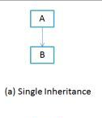
Figure

Single Inheritance example program in Java:

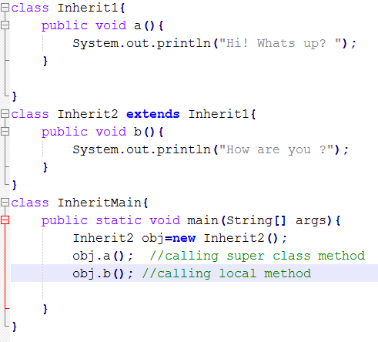

Output:

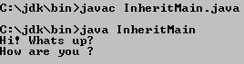

Multiple inheritance:
“Multiple Inheritance” refers to the concept of one class extending (Or inherits) more than one base class. The inheritance we learnt earlier had the concept of one base class or parent. The problem with “multiple inheritance” is that the derived class will have to manage the dependency on two base classes.

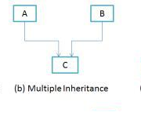
Figure

Note 1: Multiple Inheritance is very rarely used in software projects. Using Multiple inheritance often leads to problems in the hierarchy. This results in unwanted complexity when further extending the class.
Note 2: Most of the new OO languages like Small Talk, Java, C# do not support Multiple inheritance. Multiple Inheritance is supported in C++.

Multi-level inheritance:
Multilevel inheritance refers to a mechanism in OO technology where one can inherit from a derived class, thereby making this derived class the base class for the new class. As you can see in below flow diagram C is subclass or child class of B and B is a child class of A.

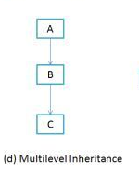
Figure

Multilevel Inheritance example program in Java:

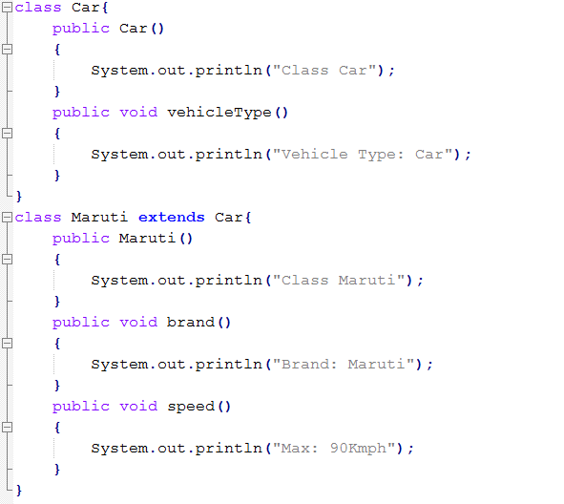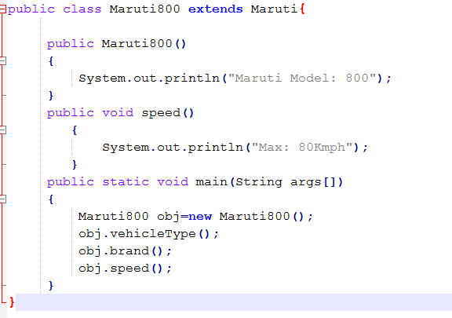
Output:

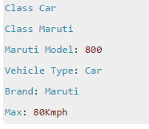
Conclusion:
Inheritance is one of the key features of Object Oriented Programming. Inheritance provided mechanism that allowed a class to inherit property of another class. When a Class extends another class it inherits all non-private members including fields and methods. Inheritance in Java can be best understood in terms of Parent and Child relationship, also known as Super class(Parent) and Sub class(child) in Java language.
Note:
- Multiple inheritance is not supported in java
- To remove ambiguity
- To provide more maintainable and clear design.

Review Questions
Q#1: Does Java support Multiple inheritance?

______________________________________________________________________________________________________________________________________________________________________________________________________

Q#2:What is Inheritance in Java Programming?

_____________________________________________________________________________________________________________________________________________________________________________________________________

Q#3: How does single level inheritance inherit from base class?

_____________________________________________________________________________________________________________________________________________________________________________________________________

Q#4: Difference between Multi-level and Multiple inheritance in java?

_____________________________________________________________________________________________________________________________________________________________________________________________________

Q#5: Whenever, we have single level inheritance then why did we require Multi-level inheritance in java?

______________________________________________________________________________________________________________________________________________________________________________________________________

PRACTICAL#11
OBJECTIVE:
- To become familiar with creation & running of simple applet program in java.
Apparatus:
- A machine with pre-installed JDK, Notepad
THEORY:
An applet is a Java program, which can be downloaded from a remote server and executes inside the web browser of the local machine. Applets are executed inside the browser via the so-called "Java Plug-in", which is a JRE capable of running Java applets in a secure manner (just like most web browsers have plug-ins for running flash, JavaScript, VBScript and other programs).
There are some important differences between an applet and a standalone Java application, including the following:
- An applet is a Java class that extends the java.applet.Applet class.
- A main() method is not invoked on an applet, and an applet class will not define main().
- Applets are designed to be embedded within an HTML page.
- When a user views an HTML page that contains an applet, the code for the applet is downloaded to the user's machine.
- A JVM is required to view an applet. The JVM can be either a plug-in of the Web browser or a separate runtime environment.
- The JVM on the user's machine creates an instance of the applet class and invokes various methods during the applet's lifetime.
- Applets have strict security rules that are enforced by the Web browser. The security of an applet is often referred to as sandbox security, comparing the applet to a child playing in a sandbox with various rules that must be followed.
- Other classes that the applet needs can be downloaded in a single Java Archive (JAR) file.

Life Cycle of an Applet:
Four methods in the Applet class give you the framework on which you build any serious applet:
- init: This method is intended for whatever initialization is needed for your applet. It is called after the param tags inside the applet tag have been processed.
- start: This method is automatically called after the browser calls the init method. It is also called whenever the user returns to the page containing the applet after having gone off to other pages.
- stop: This method is automatically called when the user moves off the page on which the applet sits. It can, therefore, be called repeatedly in the same applet.
- destroy: This method is only called when the browser shuts down normally. Because applets are meant to live on an HTML page, you should not normally leave resources behind after a user leaves the page that contains the applet.
- paint: Invoked immediately after the start() method, and also any time the applet needs to repaint itself in the browser. The paint() method is actually inherited from the java.awt

A "Hello, World" Applet:

The following is a simple applet named HelloWorldApplet.java:
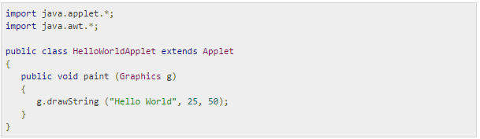

These import statements bring the classes into the scope of our applet class:
- java.applet.Applet.
- java.awt.Graphics.
Without those import statements, the Java compiler would not recognize the classes Applet and Graphics, which the applet class refers to.

Invoking an Applet:
An applet may be invoked by embedding directives in an HTML file and viewing the file through an applet viewer or Java-enabled browser.
The <applet> tag is the basis for embedding an applet in an HTML file. Below is an example that invokes the "Hello, World" applet:
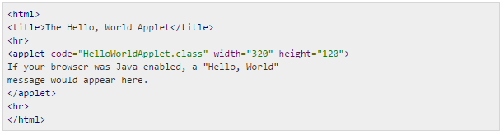

Event Handling:
Applets inherit a group of event-handling methods from the Container class. The Container class defines several methods, such as processKeyEvent and processMouseEvent, for handling particular types of events, and then one catch-all method called processEvent.
In order to react an event, an applet must override the appropriate event-specific method.
importjava.awt.event.MouseListener;
importjava.awt.event.MouseEvent;
importjava.applet.Applet;
importjava.awt.Graphics;

publicclassExampleEventHandlingextendsAppletimplementsMouseListener{

StringBufferstrBuffer;

publicvoidinit(){
addMouseListener(this);
strBuffer=newStringBuffer();
addItem("initializing the apple ");
}

publicvoid start(){
addItem("starting the applet ");
}

publicvoid stop(){
addItem("stopping the applet ");
}

publicvoid destroy(){
addItem("unloading the applet");
}

voidaddItem(String word){
System.out.println(word);
strBuffer.append(word);
repaint();
}

publicvoid paint(Graphics g){
//Draw a Rectangle around the applet's display area.
g.drawRect(0,0,
getWidth()-1,
getHeight()-1);

//display the string inside the rectangle.
g.drawString(strBuffer.toString(),10,20);
}

publicvoidmouseEntered(MouseEventevent){
}
publicvoidmouseExited(MouseEventevent){
}
publicvoidmousePressed(MouseEventevent){
}
publicvoidmouseReleased(MouseEventevent){
}

publicvoidmouseClicked(MouseEventevent){
addItem("mouse clicked! ");
}
}
Now, let us call this applet as follows:
<html>
<title>Event Handling</title>
<hr>
<appletcode="ExampleEventHandling.class"
width="300"height="300">
</applet>
<hr>
</html>

Summary:
You include applets in HTML pages using the <APPLET> tag. When a browser user visits a page that contains an applet, here's what happens:
- The browser finds the class file for the applet's Applet subclass. The location of the class file (which contains Java bytecodes) is specified with the CODE and CODEBASE attributes of the<APPLET> tag.
- The browser brings the bytecodes over the network to the user's computer.
- The browser creates an instance of the Applet subclass. When we refer to an applet, we're generally referring to this instance.
- The browser calls the applet's init method. This method performs any one-time initialization that is required.
- The browser calls the applet's start method. This method often starts a thread to perform the applet's duties.
Exercise
1:- Which method is called first by an applet?
[A] start() [B] run()
[C] init() [D] paint()
2:- To display text on the applet........method is used.
[A] showString() [B] drawString()
[C] println() [D] printString()
3:- The Applet class is in ...........package
[A] java.applet [B] java.awt
[C] java.io [D] java.util
4:- Which method can be used to draw a rectangle in the a Applet?
[A] drawRect() [B] drawPolygon()
[C] drawLine() [D] all of these
5:- How many way to run applet
[A] 1 [B] 2
[C] 3 [D] 4

6:- Explain with an example how we implement an applet into a web page using applet tag.
_______________________________________________________________________________________________________________________________________________________________________________________________________________________________________________________________
7:- What is the difference between an Applet and an Application?
____________________________________________________________________________________________________________________________________________________________________________________________________________________________________________________________________________________________________________________________________________________

PRACTICAL#12
Objective:
To become familiar GUI with event handling programming in java.

Apparatus:
- A machine with pre-installed JDK, Notepad
Theory
Event Handling is the mechanism that controls the event and decides what should happen if an event occurs. This mechanism have the code which is known as event handler that is executed when an event occurs. Java Uses the Delegation Event Model to handle the events. This model defines the standard mechanism to generate and handle the events. Let's have a brief introduction to this model.
The Delegation Event Model has the following key participants namely:
- Source - The source is an object on which event occurs. Source is responsible for providing information of the occurred event to it's handler. Java provide as with classes for source object.
- Listener - It is also known as event handler. Listener is responsible for generating response to an event. From java implementation point of view the listener is also an object. Listener waits until it receives an event. Once the event is received , the listener process the event an then returns.

Example: Implementing GUI for awt control.
importjava.awt.*;
importjava.awt.event.*;
public class AwtControlDemo {
private Frame mainFrame;
private Label headerLabel;
private Label statusLabel;
private Panel controlPanel;
publicAwtControlDemo(){
prepareGUI(); }

public static void main(String[] args){
AwtControlDemoawtControlDemo = new AwtControlDemo();
awtControlDemo.showEventDemo(); }
private void prepareGUI(){
mainFrame = new Frame("Java AWT Examples");
mainFrame.setSize(400,400);
mainFrame.setLayout(new GridLayout(3, 1));
mainFrame.addWindowListener(new WindowAdapter() {
public void windowClosing(WindowEventwindowEvent){
System.exit(0); } });
headerLabel = new Label();
headerLabel.setAlignment(Label.CENTER);
statusLabel = new Label();
statusLabel.setAlignment(Label.CENTER);
statusLabel.setSize(350,100);
controlPanel = new Panel();
controlPanel.setLayout(new FlowLayout());
mainFrame.add(headerLabel);
mainFrame.add(controlPanel);
mainFrame.add(statusLabel);
mainFrame.setVisible(true); }
private void showEventDemo(){
headerLabel.setText("Control in action: Button");
Button okButton = new Button("OK");
Button submitButton = new Button("Submit");
Button cancelButton = new Button("Cancel");
okButton.setActionCommand("OK");
submitButton.setActionCommand("Submit");
cancelButton.setActionCommand("Cancel");
okButton.addActionListener(new ButtonClickListener());
submitButton.addActionListener(new ButtonClickListener());
cancelButton.addActionListener(new ButtonClickListener());
controlPanel.add(okButton);
controlPanel.add(submitButton);
controlPanel.add(cancelButton);
mainFrame.setVisible(true); }

private class ButtonClickListener implements ActionListener{
public void actionPerformed(ActionEvent e) {
String command = e.getActionCommand();
if(command.equals( "OK" )) {
statusLabel.setText("Ok Button clicked.");
}
else if( command.equals( "Submit" ) ) {
statusLabel.setText("Submit Button clicked."); }
else {
statusLabel.setText("Cancel Button clicked.");
} } }}
Conclusion
To familiar with GUI event handling .Elementary java program were written and tested to learn basic concepts of event handling programming and usage in java.

Exercise
1.Write a java application to calculate factorial of number entered by user using event handling
GUI.
2.Write java application on different event:
a) Action Event
b) Item Event
c) Mouse Event
d) Key Event
3.Write an AWT GUI application. Each time the "Count" button is clicked, the counter value
shall increase by 1.

Reviews
Q1. Describe the event-handling model in java .
______________________________________________________________________________
______________________________________________________________________________
______________________________________________________________________________
Q2. Describe various methods from key Listener interface. What are the mouse event-handling interfaces and their corresponding methods? Explain in brief.
______________________________________________________________________________
______________________________________________________________________________
______________________________________________________________________________
Q3. Describe various methods from Mouse Listener interface.
______________________________________________________________________________
______________________________________________________________________________
______________________________________________________________________________

Q4. What is delegation event model in java? Explain in brief.
______________________________________________________________________________
______________________________________________________________________________
______________________________________________________________________________
Q5. Describe various interfaces and classes from package AWT.
______________________________________________________________________________
______________________________________________________________________________
______________________________________________________________________________

PRACTICAL#13
Objective:
To become familiar with Exception Handling mechanism in Java.
Apparatus:
- A machine with pre-installed JDK, Notepad
Theory:
An exception (or exceptional event) is a problem that arises during the execution of a program. When an Exception occurs the normal flow of the program is disrupted and the program/Application terminates abnormally, which is not recommended, therefore these exceptions are to be handled.
Exception Hierarchy:
All exception classes are subtypes of the java.lang.Exception class. The exception class is a subclass of the Throwable class. Other than the exception class there is another subclass called Error which is derived from the Throwable class.
Errors are not normally trapped form the Java programs. These conditions normally happen in case of severe failures, which are not handled by the java programs. Errors are generated to indicate errors generated by the runtime environment. Example: JVM is out of Memory. Normally programs cannot recover from errors.
The Exception class has two main subclasses: IOException class and RuntimeException Class.
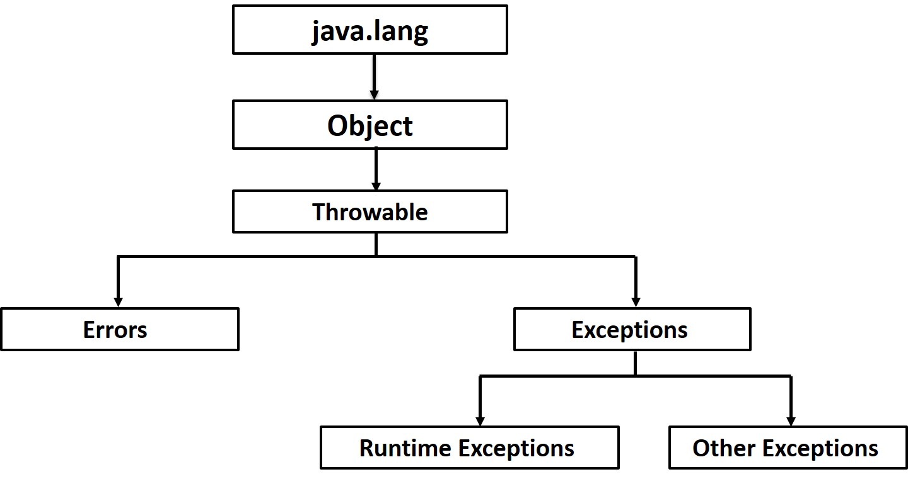
Java Exception Handling Keywords
There are 5 keywords used in java exception handling.
- try
- catch
- finally
- throw
- throws
Java try block
Java try block is used to enclose the code that might throw an exception. It must be used within the method.
Java try block must be followed by either catch or finally block.
Java catch block
Java catch block is used to handle the Exception. It must be used after the try block only.
You can use multiple catch block with a single try.
Java throw keyword
The Java throw keyword is used to explicitly throw an exception.
We can throw either checked or unchekedexception in java by throw keyword. The throw keyword is mainly used to throw custom exception.
Java throws keyword
The Java throws keyword is used to declare an exception. It gives an information to the programmer that there may occur an exception so it is better for the programmer to provide the exception handling code so that normal flow can be maintained.
Exception Handling is mainly used to handle the checked exceptions. If there occurs any unchecked exception such as NullPointerException, it is programmers fault that he is not performing check up before the code being used.
Java finally block
Java finally block is a block that is used to execute important code such as closing connection, stream etc.
Java finally block is always executed whether exception is handled or not.
Java finally block must be followed by try or catch block.

Example programs:
The following is an array is declared with 2 elements. Then the code tries to access the 3rd element of the array which throws an exception.
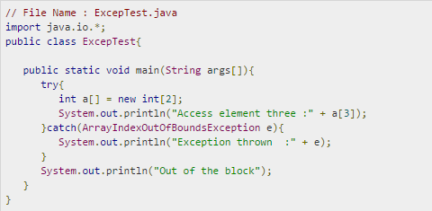
This would produce the following result:
Example 2:
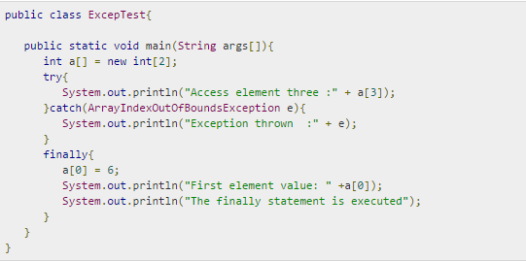
This would produce the following result:
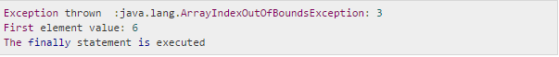

Review Questions:
1- What is Exception in Java?

2- Define exception handling keywords in java briefly.

3- What is difference between throw and throws keyword in Java?

4- What happens when exception is thrown by main method?

5- What is the difference between error and exception?

PRACTICAL#14
Objective:
To become familiar with two ways to implement threads in java
Apparatus:
- A machine with pre-installed JDK, Notepad
Theory:
A Thread is a single sequence of execution within a program. An executing instance of a program is called a process. A thread is a subset of the process. Threads share the address space of the process that created it, processes have their own address space. Multithreading refers to multiple threads of control within a single program.
When we execute an Application:
- The JVM creates a Thread object whose task is defined by the main() method.
- It starts the Threads.
- The thread executes the statements of the program one by one until the method returns and the thread dies.

There are two ways to creating our own Thread object.
- Subclassing the Thread class and instantiating a new object of that class.
- Implementing the Runnable() method should be implemented.
In both cases the run() method should be implemented.

Steps involved into these two ways are:
- a. Extend a class from the thread class.
b. Override the run() method.
c. Create and instance of the above class.
d. start the threads.

- a. Implementing Runnable on a class.
b. Implementing the run() method of the runnable interface.
c. Create an instance of the class.
d. Create a thread object by passing the runnable object as parameter.
e. start the thread (by calling).

If you are not passing runnable object as parameter and you call start() then it will automatic call the runnable threads because start() itself as runnable thread. That’s why we can directly call the start() not runnable method.

Lets see the example of first way of thread by extending thread class:

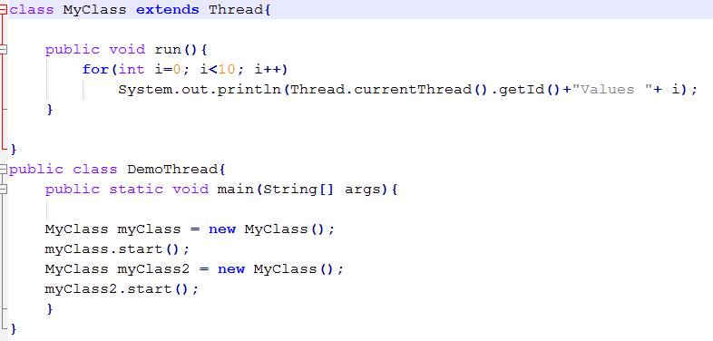
Output:
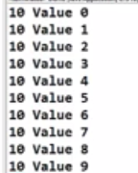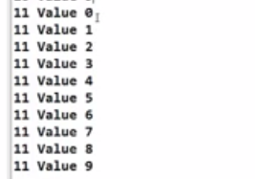
In this first case of thread you can see what is happening here So, here you can see the thread number , so the number is given through to the thread and is this case the number 10 is given to thread one and number 11 is given to thread two. Right !andits using thread printing values from 0 to 9 and it is going to take thread two the printing its value from 0 to 9 right! But they are running in sequence right now.
Now let see the second case of thread way by implementing runnable interface:
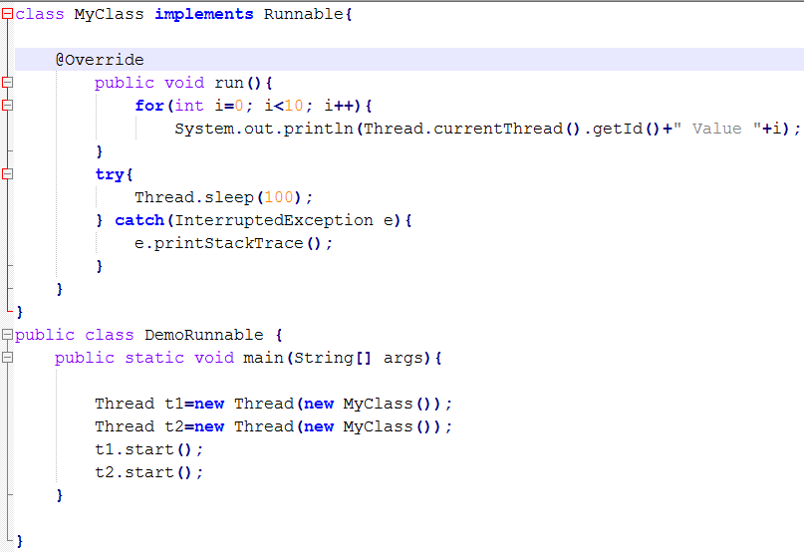
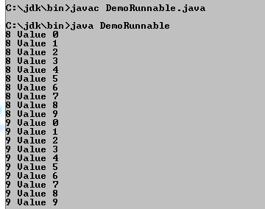
Here is also same output as above program’s output but change is that the start() method will override on run() method hence it performs two threads concurrently.

Conclusion:
- To maintain responsiveness of an application during a long running task.
- To enable cancellation of separable tasks.
- Some problems are intrinsically parallel.
- To monitor status of some resource (DB).
- Some APIs and systems demand it : Swing.

Review Questions:
Q#1: What is Multithreading & also give a example of it?
________________________________________________________________________________________________________________________________________________________________________

Q#2: Which are two ways to creating the java threads object?
________________________________________________________________________________________________________________________________________________________________________

Q#3: Which method is used in both cases to creating java thread & why?
________________________________________________________________________________________________________________________________________________________________________

Q#4: Why do we use java threads ?
________________________________________________________________________________________________________________________________________________________________________

Q#5: When start() method calls then where does run() method go ? or what happen with run() method when start() method called?
________________________________________________________________________________________________________________________________________________________________________

